PMG201c-Final Practice Examination #1
Look at projects that you are involved with, have been involved with OR the projects going on around you. Select one project in your studying fields at FU (i.e software project for SE), give the solutions or answers for following requests based on your understanding about the project & assumptions
Request 1: give detailed descriptions for the project in which you mention clearly its key characteristics: project title, project purpose/objectives (unique), project timeframe (temporary), customer/sponsor (clearly defined), project milestones (time constraints) and other project constraints (cost, resources).
Request 2: what type of organization you think the project using and what type of organization you think that should or should have used along with the reasons for this? Provide relevant reasons for your answers
Request 3: identify at least 3 significant risks that you think the project faces. For each risk determine how likely you think it is to occur (the probability) and the impact if it does occur. Create your own scoring system for probability and impact. You might use High-Medium-Low; you might use numeric values or you might use percentages. Define a response for each of these risks.
Request 4: Assume that you have defined and estimate project schedule with below high-level activities
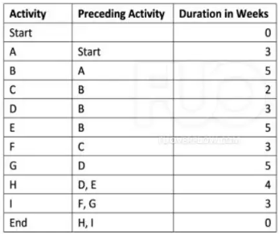
a) Use the critical path analysis technique to identify the minimum duration to complete this project
b) In the 8th week, you are executing the activity B and found that you need to speed up the project schedule to recover 3-week delay. Define 2 solutions with relevant explanation and assumptions (if needed) to achieve that (how it would help and difficulties/impacts to the project).
Request 5: Your project team have completed a workload equivalent to $3,000 and has spent $4,000 to date. Assume that you were budgeted $5,000 for the work scheduled. At the start, the team has estimated project budget of $9.000 and the project need 12 months to finish. Calculate and give your calculations and comments on the project's current status, and the forecasts to complete the project in terms of cost and schedule

